1) Create one jenkins job using the below code and create three stages.
stage1: Git clone to download the source code.
stage2: Sonarqube Integration to check the quality of code
stage3: Slack Integration to send the alerts to slack.
URL: https://github.com/betawins/VProfile-1.git

2) 1) Create one jenkins job using the below code and create three stages.
stage1: Git clone to download the source code.
stage2: Sonarqube Integration to check the quality of code
stage3: Slack Integration to send the alerts to slack.
URL: https://github.com/betawins/hiring-app.git
========================================================================

1) Create one jenkins job using the below code and create three stages.
stage1: Git clone to download the source code.
stage2: Sonarqube Integration to check the quality of code
stage3: Slack Integration to send the alerts to slack.
URL: https://github.com/betawins/VProfile-1.git

- Launched one instance, installed java and jenkins, created one job and done cloning the source code.
- 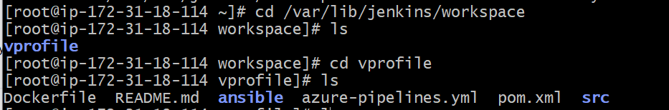
- Now launched another instance for sonar with t2.large type and installed java
- yum -y install java-1.8*
- Now install mysql.
yum update

sudo wget https://dev.mysql.com/get/mysql57-community-release-el7-11.noarch.rpm

sudo yum localinstall mysql57-community-release-el7-11.noarch.rpm

rpm --import https://repo.mysql.com/RPM-GPG-KEY-mysql-2022

sudo yum install mysql-community-server

sudo systemctl start mysqld.service

sudo systemctl status mysqld.service

- 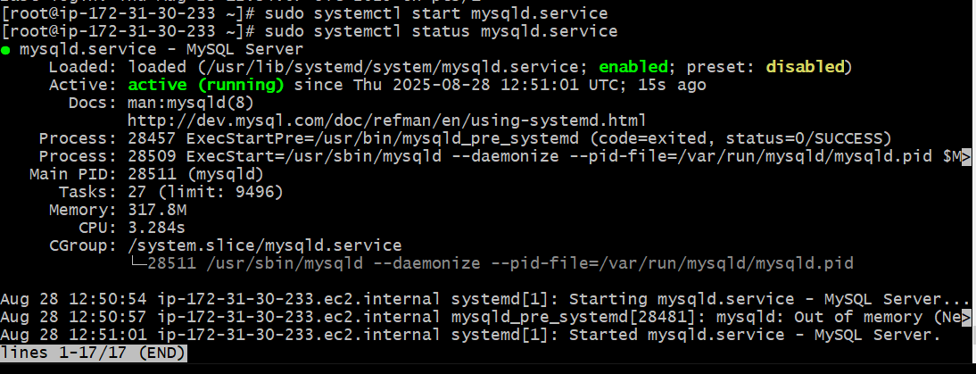
- Now change the password
- Check the password and login to myql and change
- grep 'temporary' /var/log/mysqld.log
- Then using default password login to mysql and change password
- mysql -u root -p
- ALTER USER 'root'@'localhost' IDENTIFIED BY 'Admin@12345';
- FLUSH PRIVILEGES;
- mysql -u root -p
Download SonarQube
In EC2 user (not root)
- cd /opt
wget https://binaries.sonarsource.com/Distribution/sonarqube/sonarqube-6.6.zip

unzip sonarqube-6.6.zip

mv /opt/sonarqube-6.6 /opt/sonar

- SonarQube requires a database (commonly MySQL, PostgreSQL, etc.) to store all its configuration and analysis data.
- mysql -u root -p
CREATE DATABASE sonar CHARACTER SET utf8 COLLATE utf8_general_ci;
CREATE USER 'sonar'@'localhost' IDENTIFIED BY 'Sonar@123';
CREATE USER 'sonar'@'%' IDENTIFIED BY 'Sonar@123';
GRANT ALL PRIVILEGES ON sonar.* TO 'sonar'@'localhost';
GRANT ALL PRIVILEGES ON sonar.* TO 'sonar'@'%';
FLUSH PRIVILEGES;
Now you have:
- Database → sonar
- User → sonar
- Password → Sonar@123
- ON sonar EC2 Instance (not root)
Edit sonar properties file to uncomment and provide required information for below properties.
- File Name:cd /opt/sonar/conf/sonar.properties
sonar.jdbc.username=sonar
sonar.jdbc.password=Sonar@123
sonar.jdbc.url=jdbc:mysql://localhost:3306/sonar?useUnicode=true&characterEncoding=utf8&rewriteBatchedStatements=true&useConfigs=maxPerformance&useSSL=false
sonar.web.host=0.0.0.0
sonar.web.context=/sonar
- Now in EC2 goto /opt give chown ownership to ec2-user
- Sudo chown -R ec2-user:ec2-user sonar
- cd /opt/sonar/bin/linux-x86-64
- ./sonar.sh start
- ./sonar.sh status

- 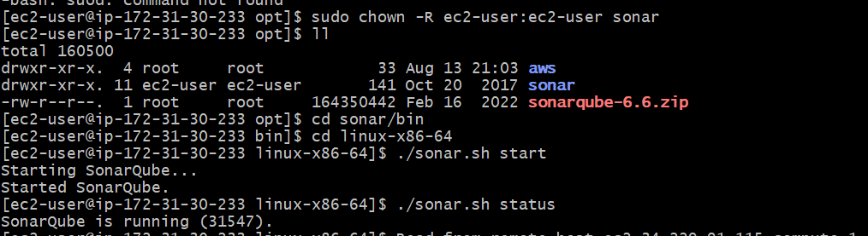
- If any thing wrong u can check logs
- 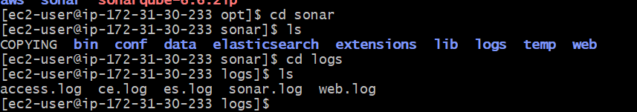
- Cd /opt/sonar/logs

Now goto browser new tab

http://34.229.91.115:9000/sonar

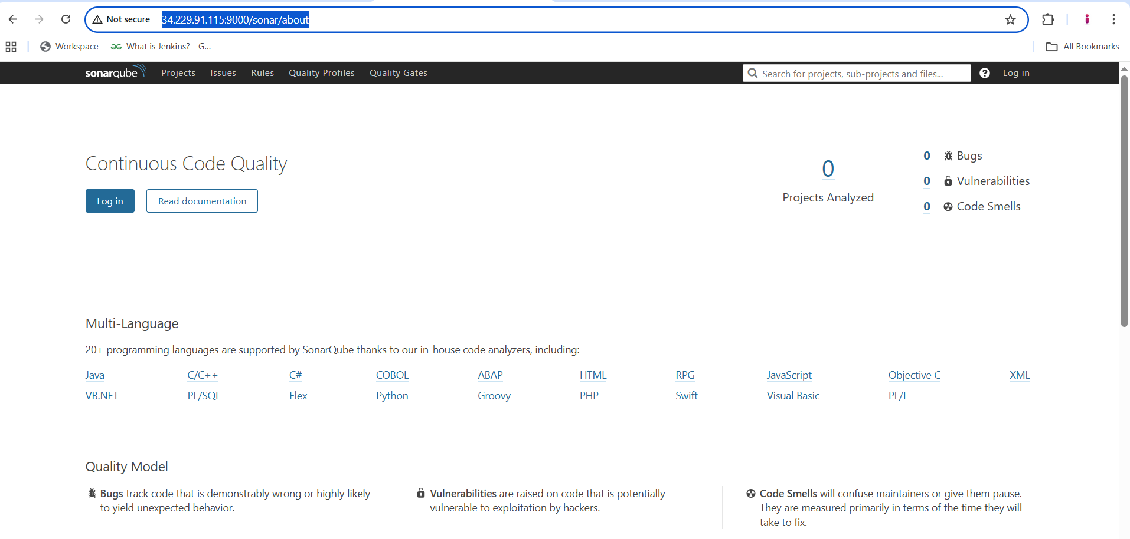

Login to sonar with default login details
admin
admin

- Now from jenkins master server → install plugin sonrqube scanner in jenkins
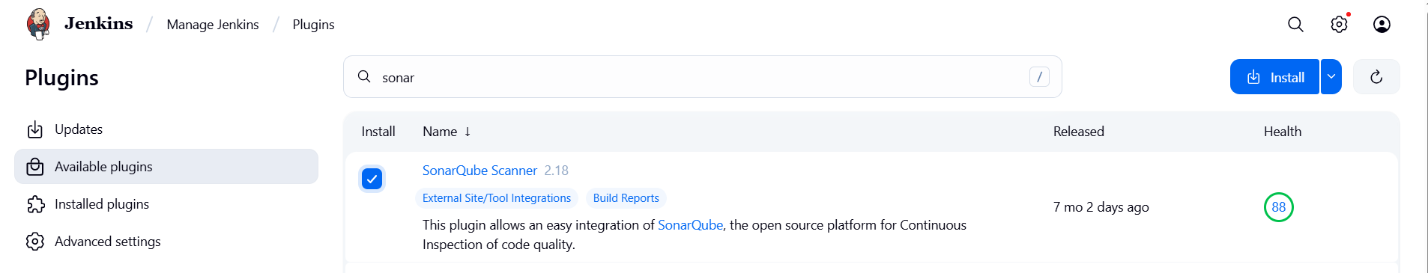
- In build setup you found sonar
- 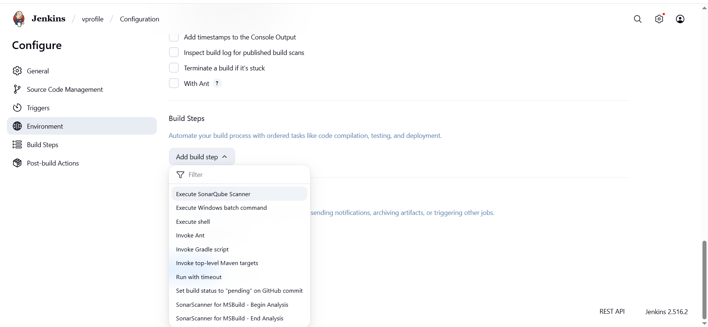
- You found sonar in system also
- 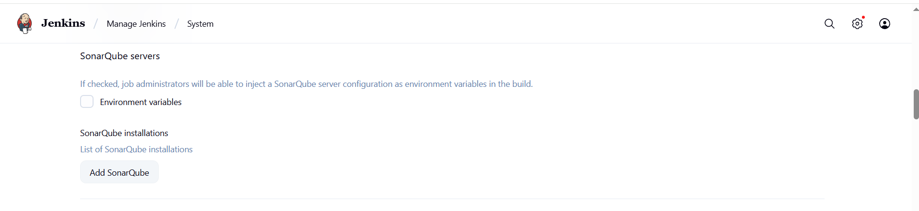
- Now add sonarqube server before that goto sonarqube page create token.
- 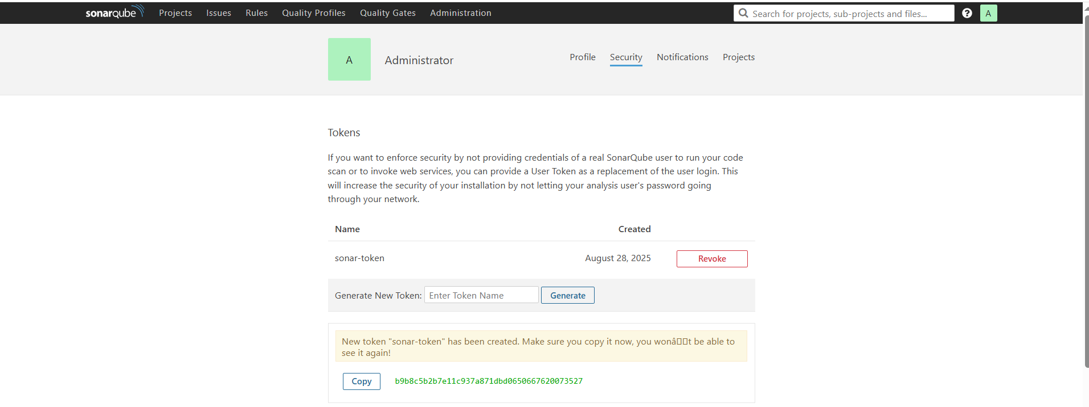
- Add the token in jenkins → credentials
- 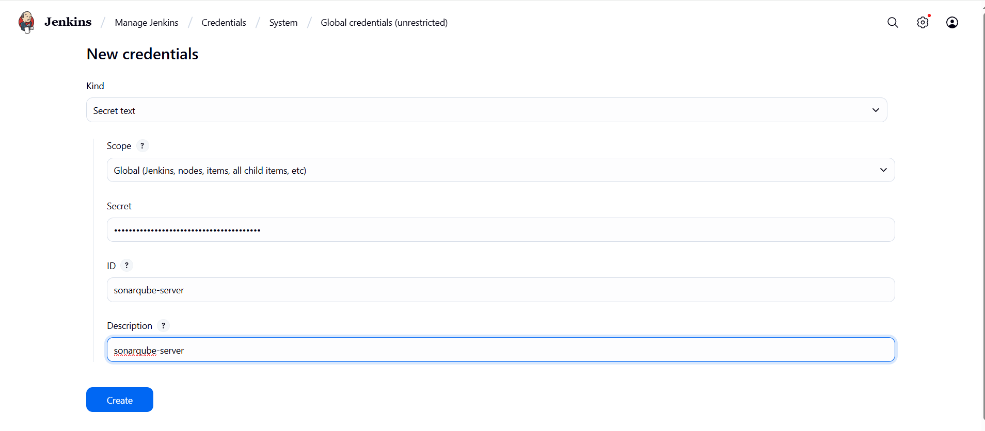
- Now add sonarqube-server
- 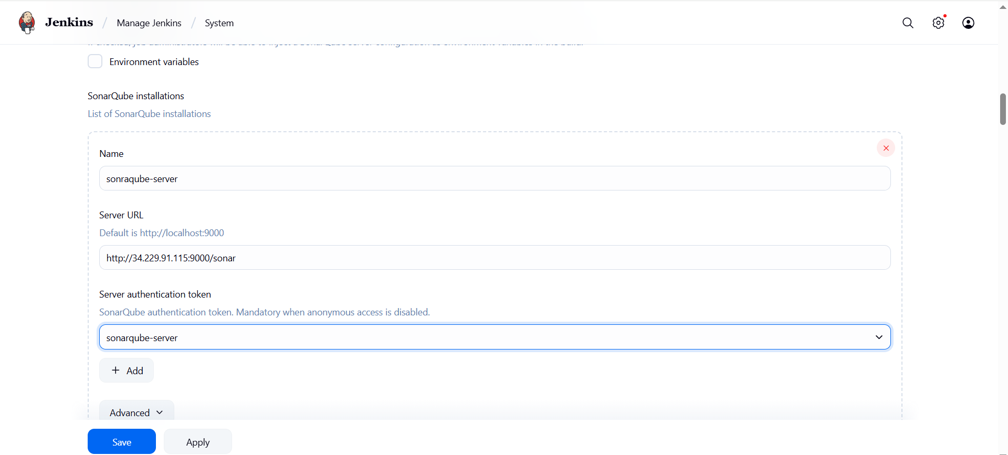
Sonar Integration with jenkins.
1. Go to jenkins server and install sonar-scanner agent

Cd /opt

wget https://binaries.sonarsource.com/Distribution/sonar-scanner-cli/sonar-scanner-cli-4.6.2.2472-linux.zip

unzip sonar-scanner-cli-4.6.2.2472-linux.zip

mv sonar-scanner-4.6.2.2472-linux /opt/sonar_scanner

in jenkins server
- cd /opt/sonar_scanner/conf
- Edit → vi sonar-scanner.properties
- Modify → sonar.host.url=http://34.229.91.115:9000/sonar
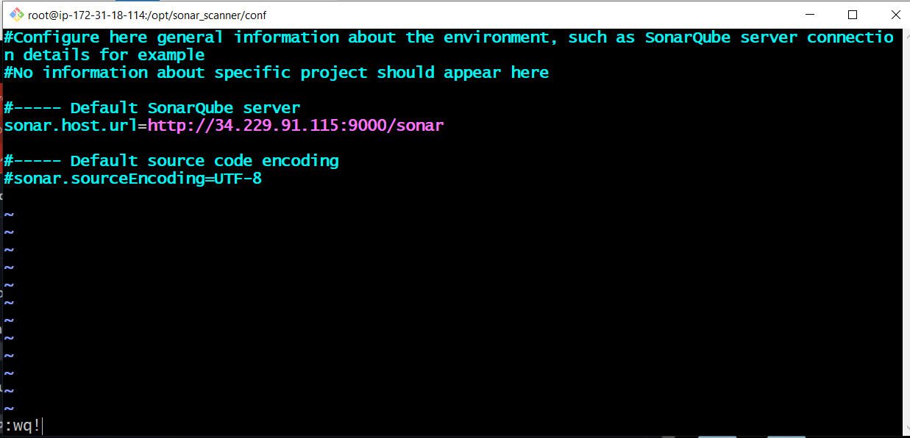

2. Goto manage jenkins tool configuration
Add sonar-scanner
/opt/sonar_scanner/
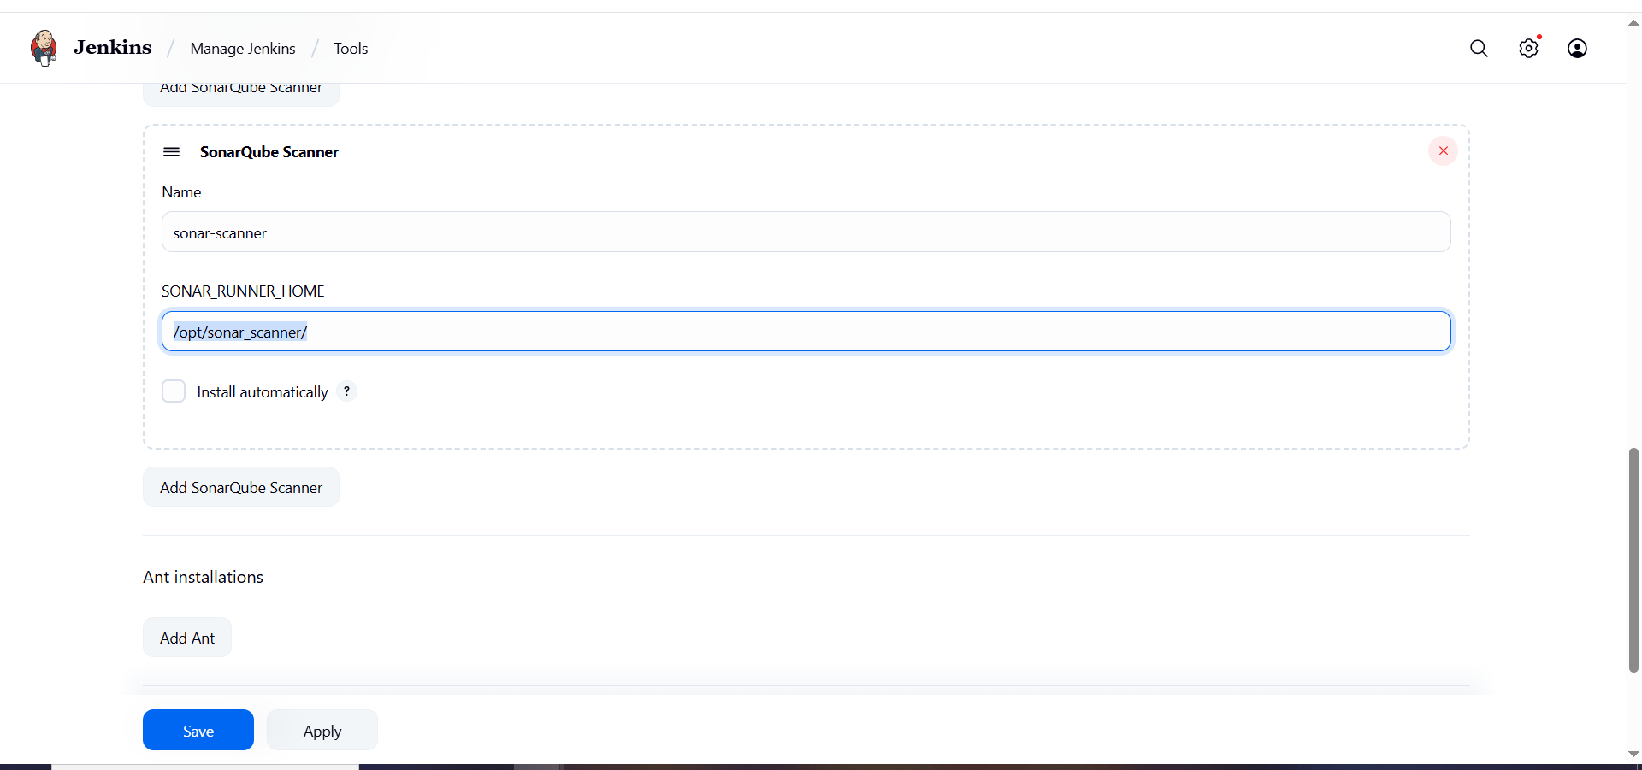

3. Now in vprofile job go to configure, add analysis properties they will mentioned in git hub repo read.me file.

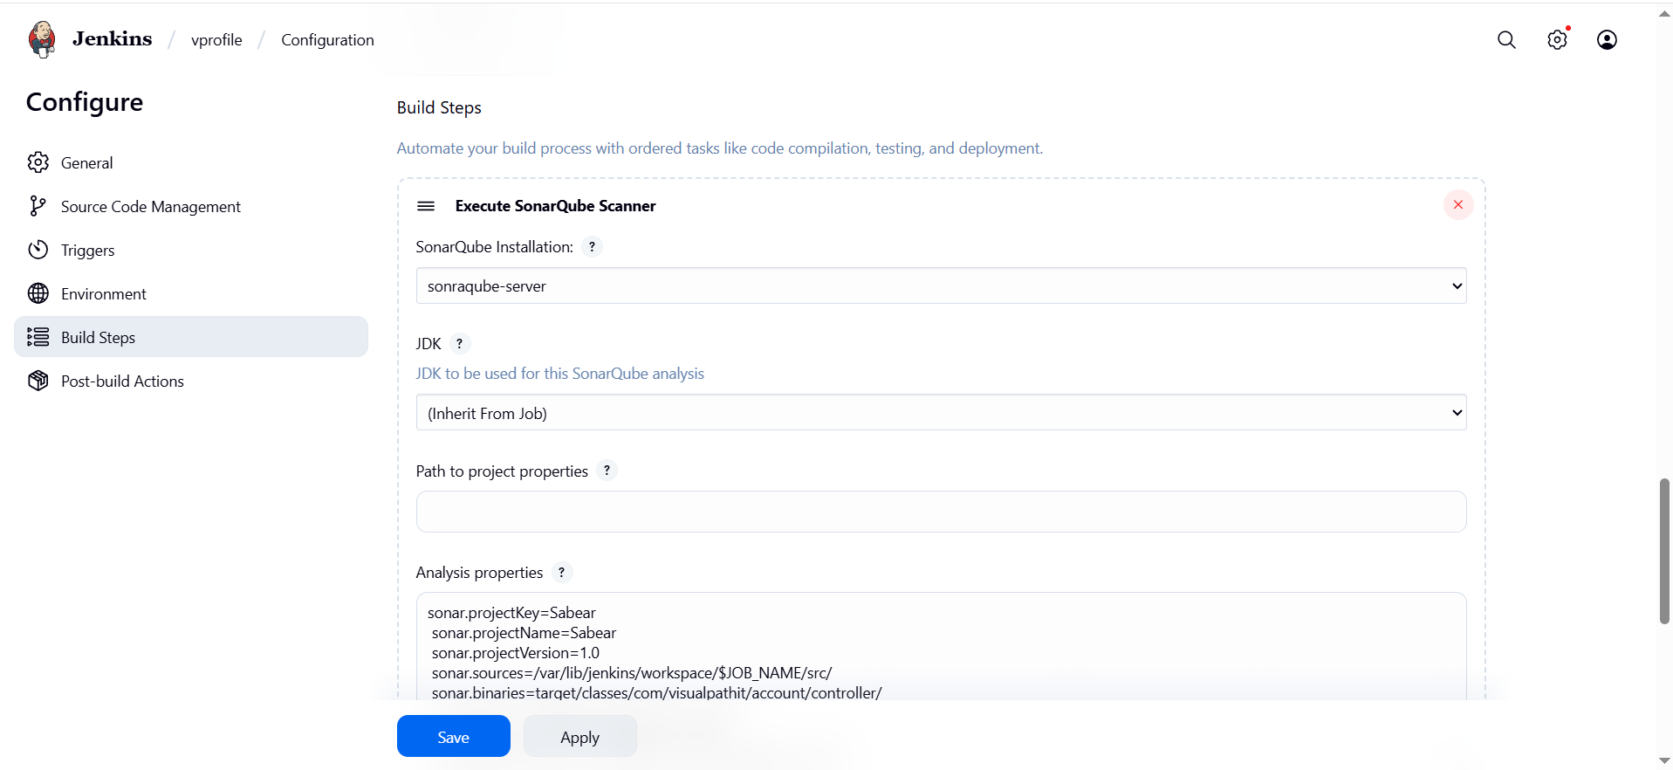
sonar.projectKey=Sabear
sonar.projectName=Sabear
sonar.projectVersion=1.0
sonar.sources=/var/lib/jenkins/workspace/$JOB_NAME/src/
sonar.binaries=target/classes/com/visualpathit/account/controller/
sonar.junit.reportsPath=target/surefire-reports
sonar.jacoco.reportPath=target/jacoco.exec
sonar.java.binaries=src/main/java/com/visualpathit/account/

4. 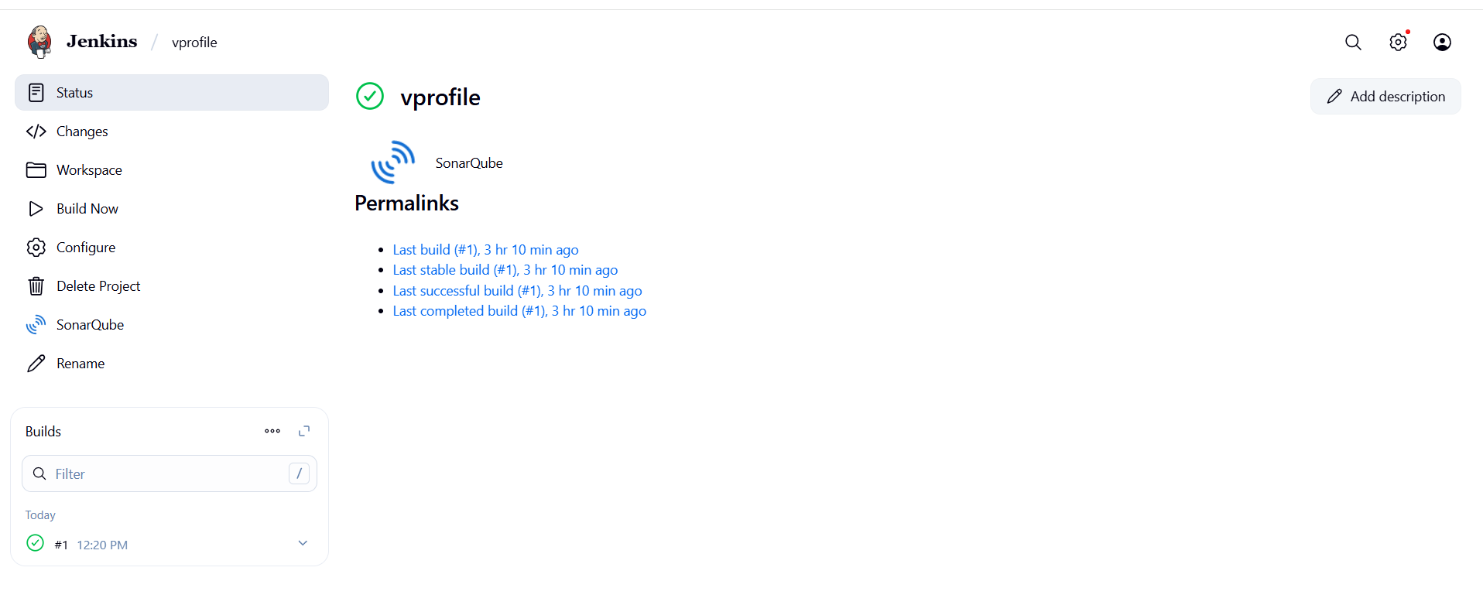5.Now build the job.
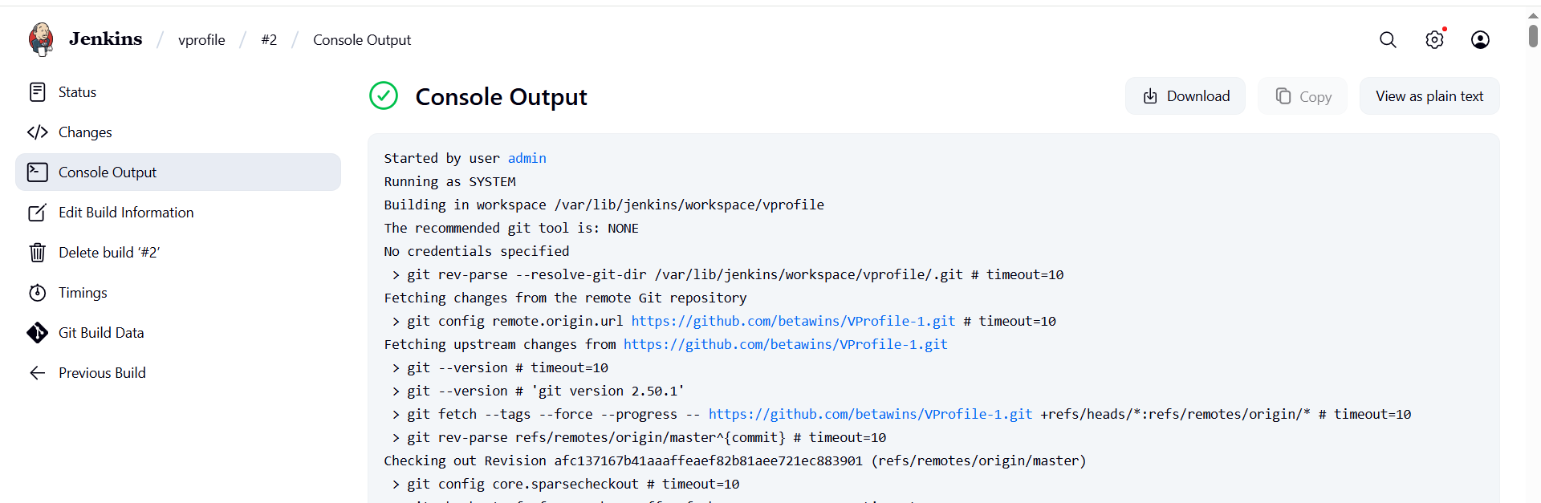
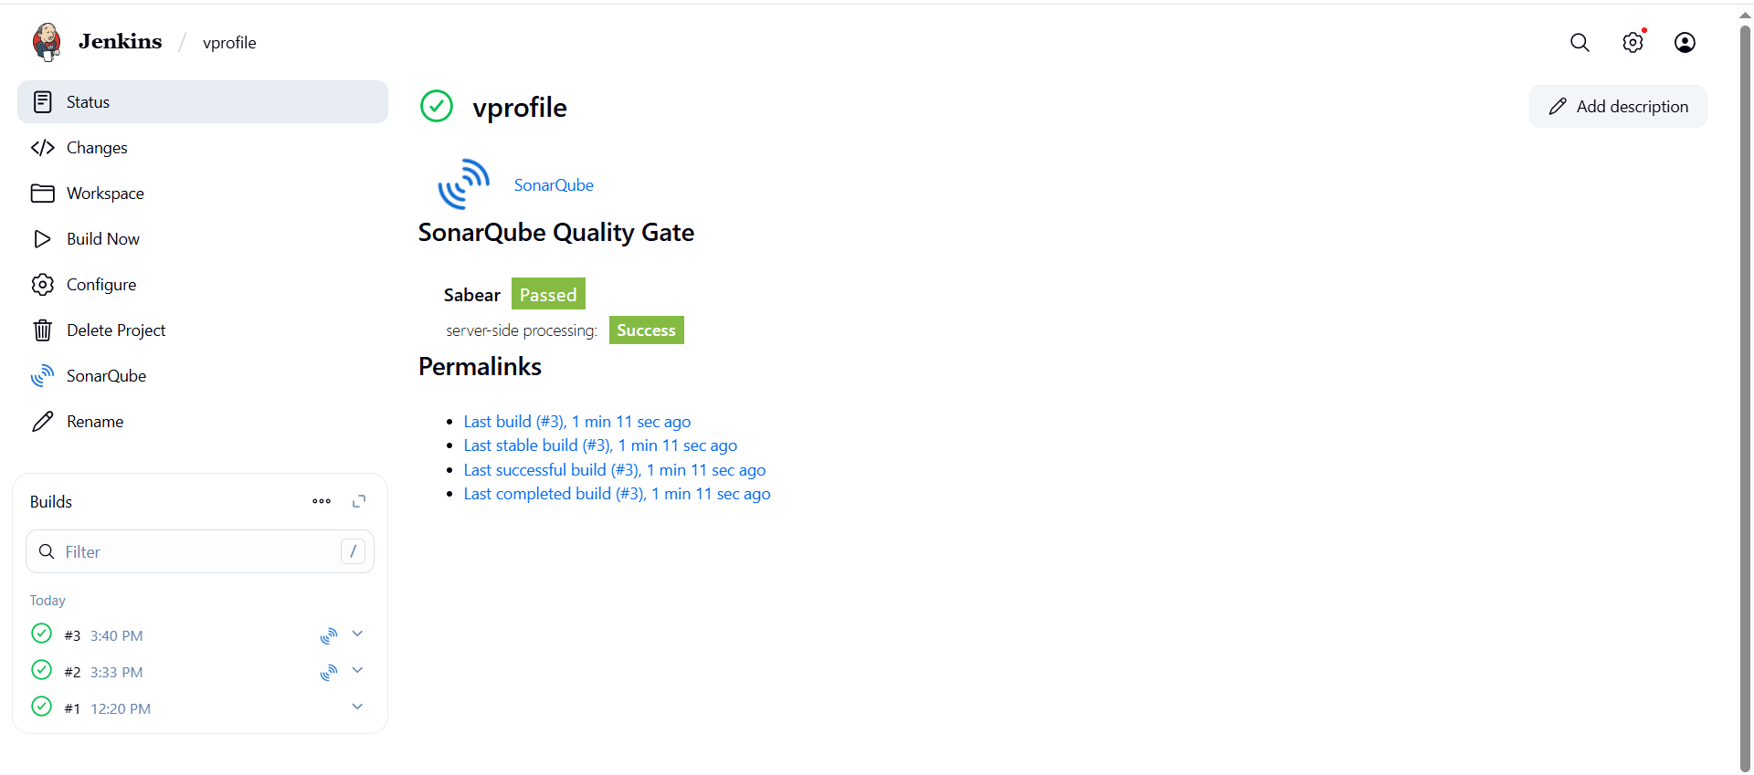
6. You can check sonarqube page.

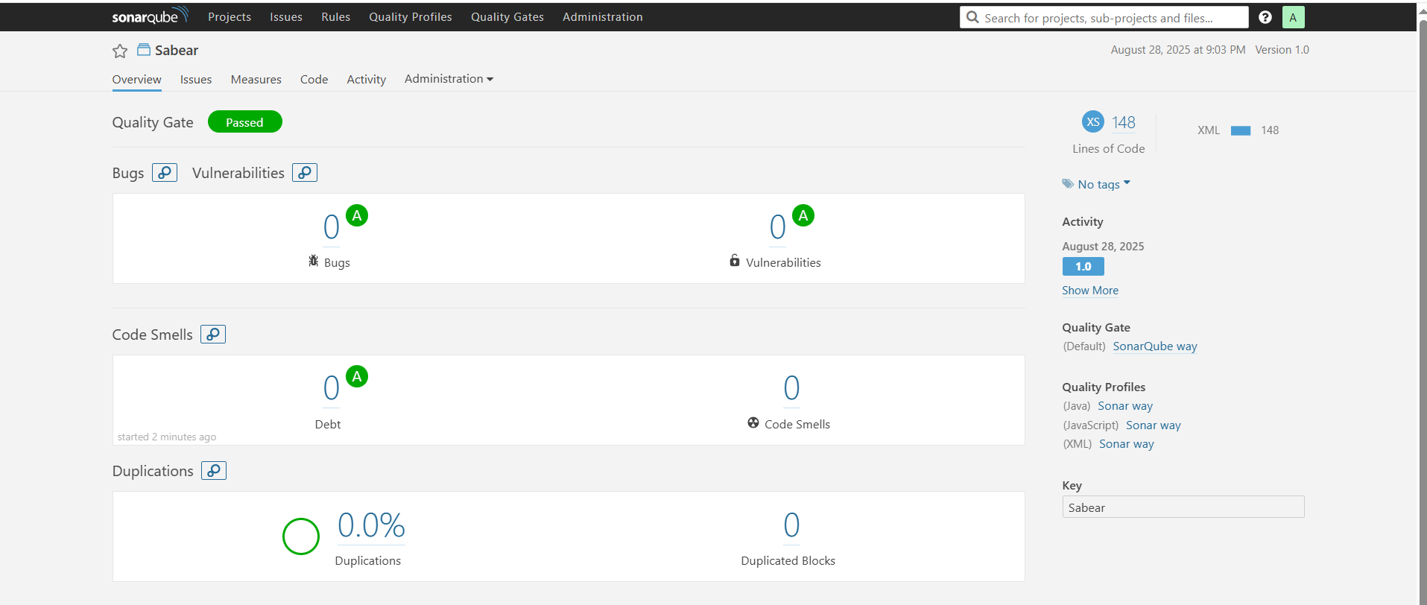

Slack notification

- Install plugin slack notification in jenkins
- Go to your slack dashboard → apps → jenkins CI → configure → add channel
- 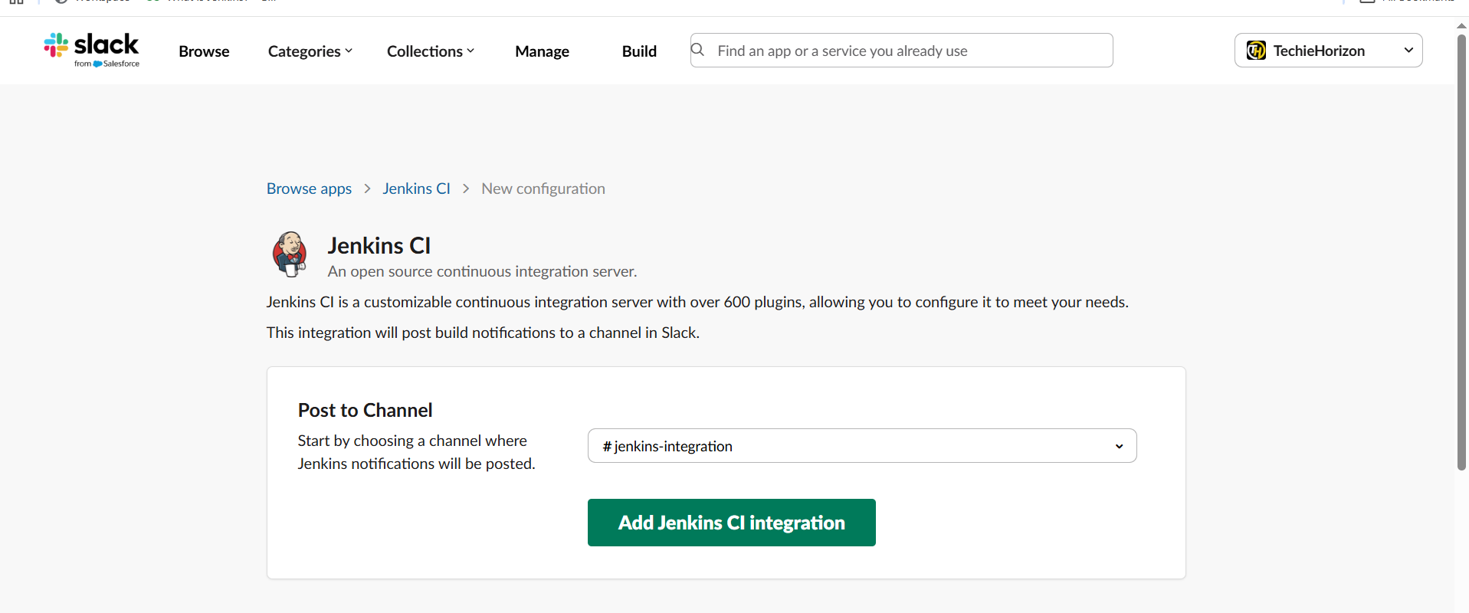
- Once add jenkins from above follow the steps.
- 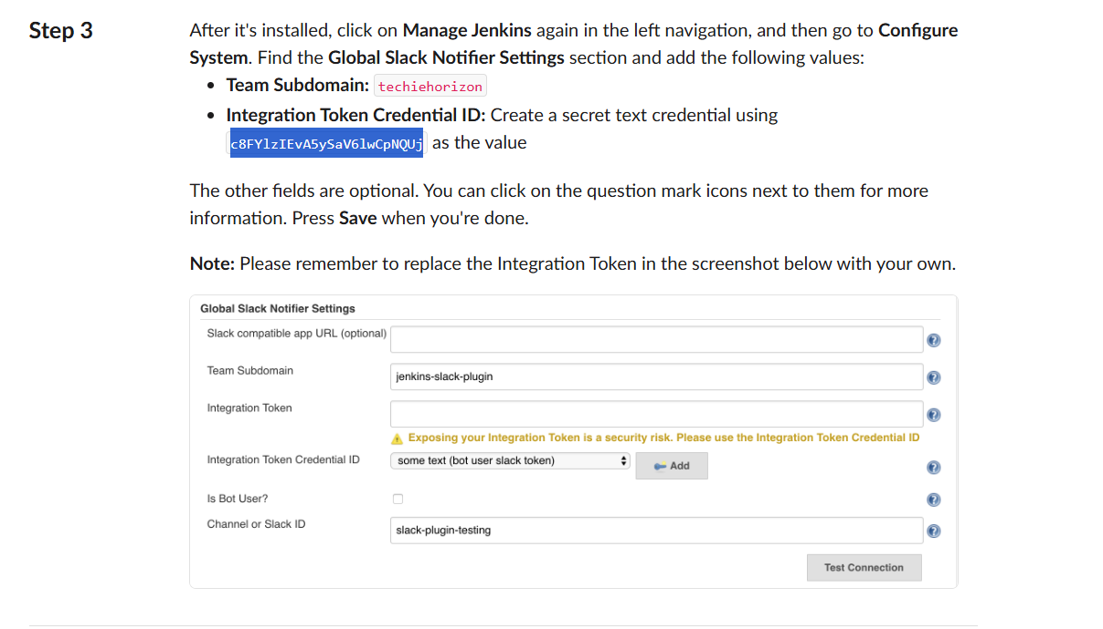
- .and add credential also Now manage jenkins → system → slack
- 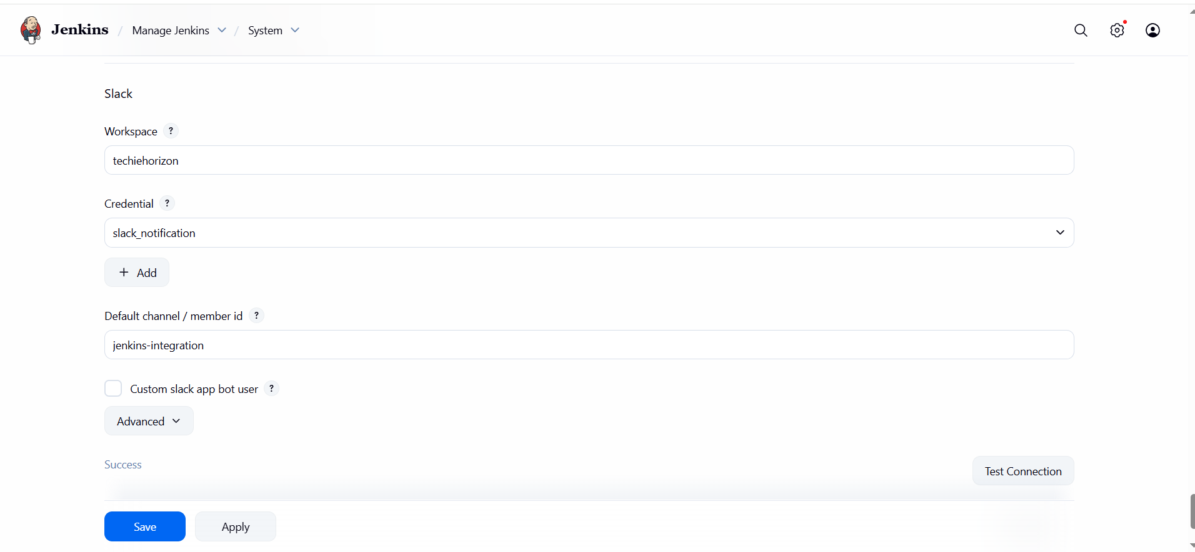
- Now in job profile post build actions , in advanced enter details.channel name or your slack id.
- 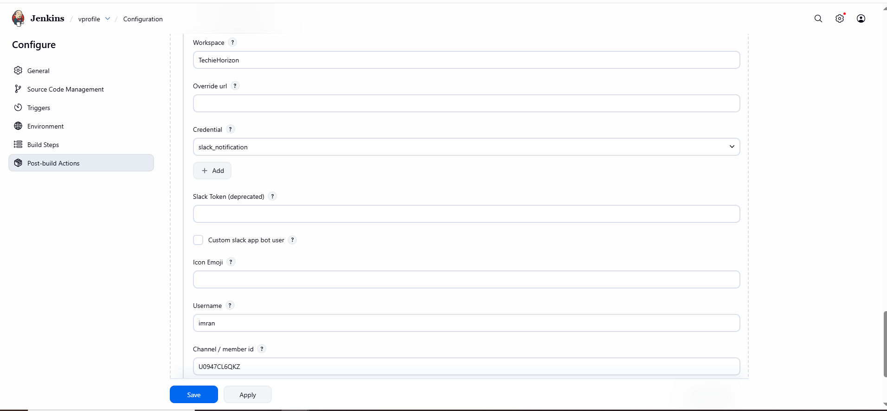
- Now build your vprofile job then after success you got notification.
- 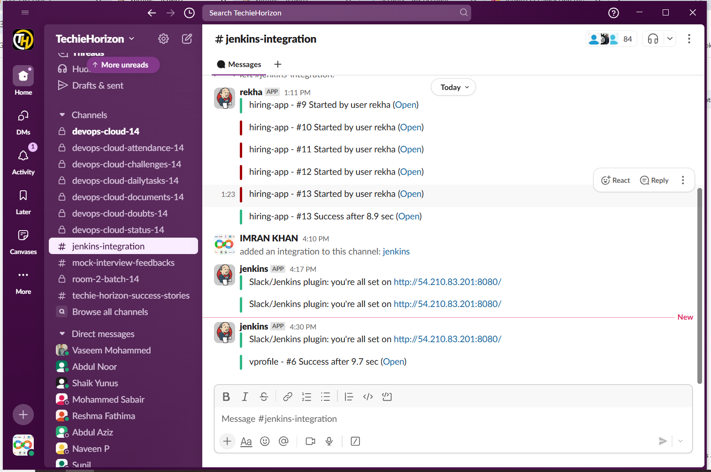
- 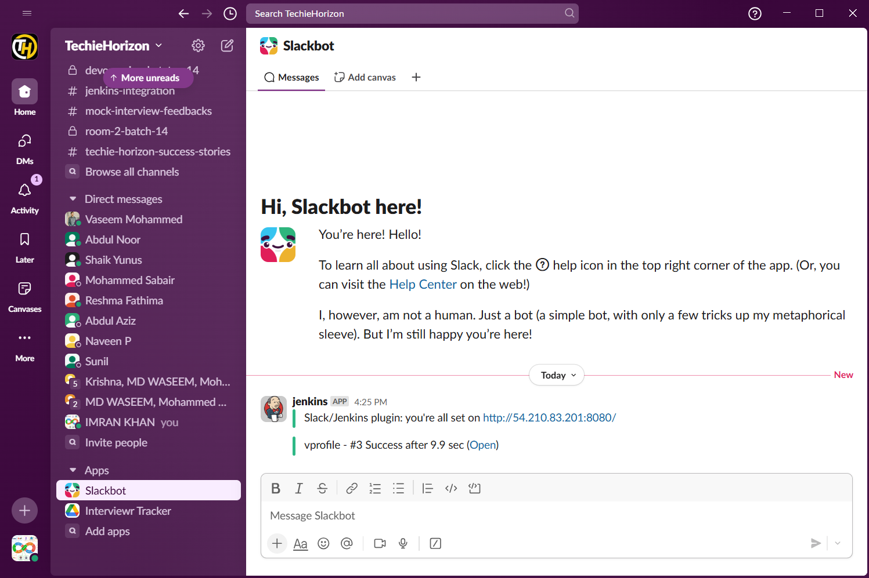
2) 1) Create one jenkins job using the below code and create three stages.
stage1: Git clone to download the source code.
stage2: Sonarqube Integration to check the quality of code
stage3: Slack Integration to send the alerts to slack.
URL: https://github.com/betawins/hiring-app.git

- In sonarqube EC2
- yum -y install docker
- systemctl start docker
- docker pull sonarqube
- Docker images
- docker run -itd -p 9002:9000 sonarqube
- Docker ps
- Now go to jenkins server and change port info
- cd /opt/sonar_scanner/conf
- Vi sonar-scanner.properties
sonar.host.url=http://184.73.14.134:9002
- Manage jenkins → system change port info of sonarqube and add credentials
- Go to sonarqube and create token
- 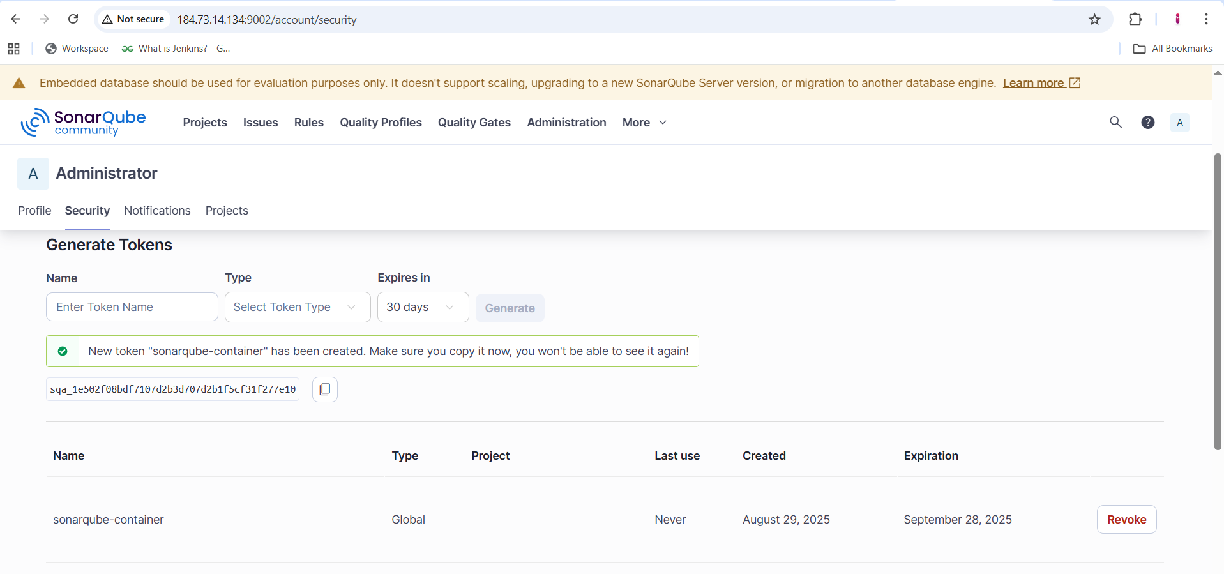
- Now go to jenkins system and add details
- 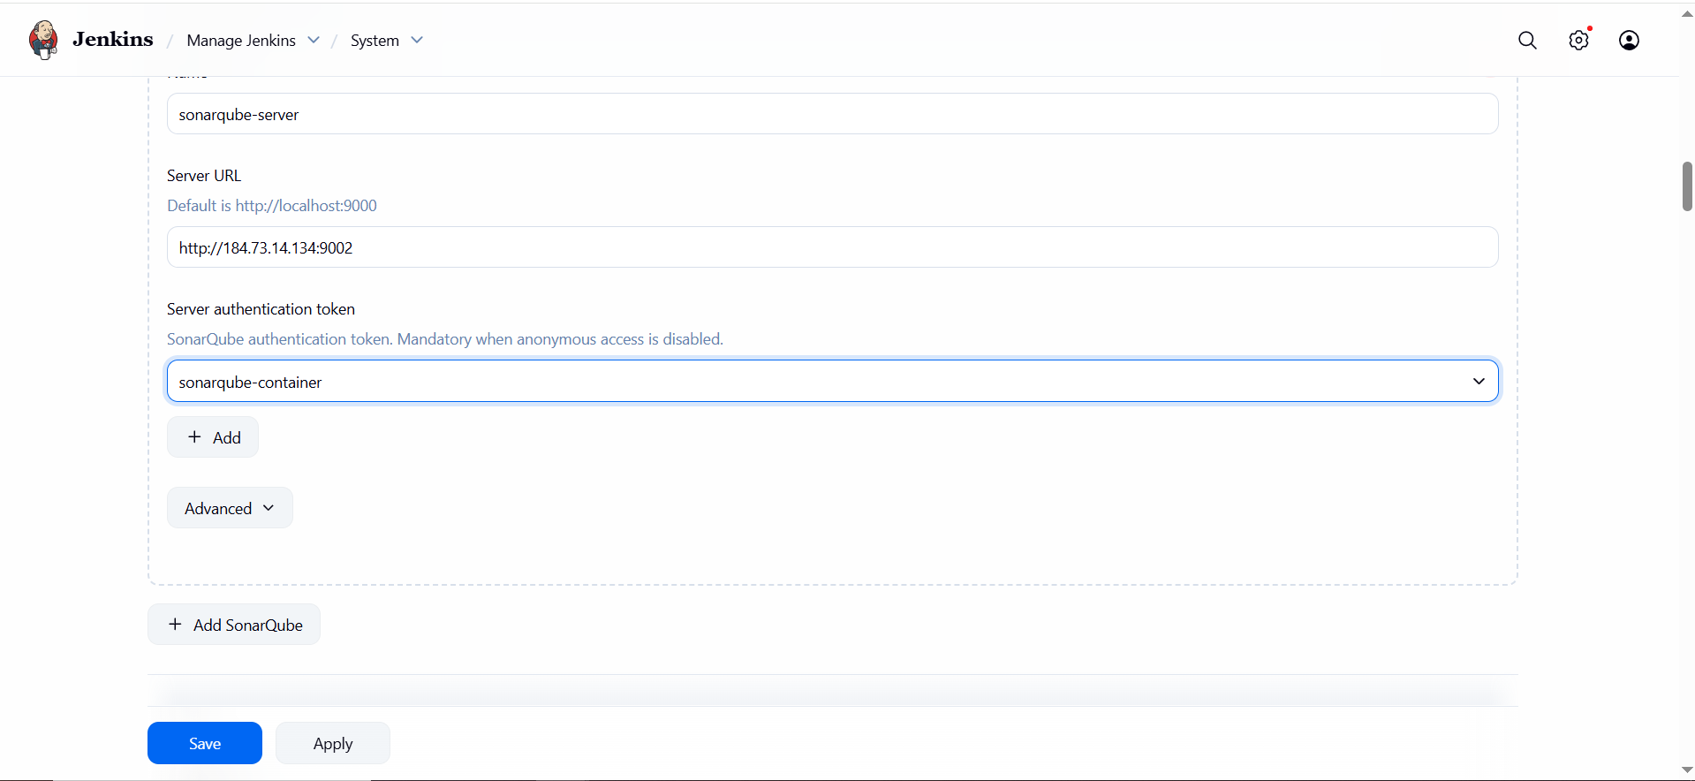
- Now try to build the hiring app
- 
 